Recruitment Information Pack

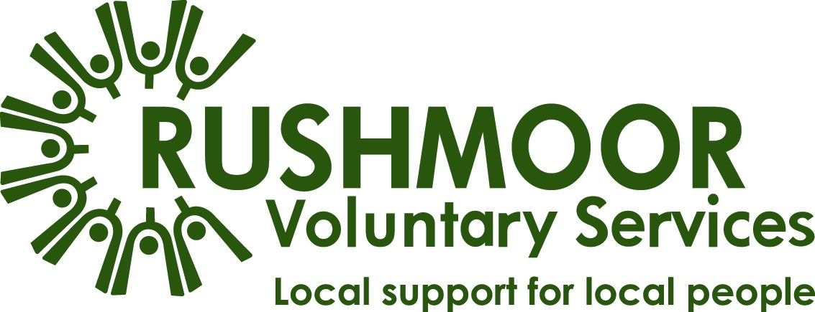

Health Walks Development Officer

To apply:
Please apply by sending your CV (including current salary) and a supporting statement to beverley.jones@rvs.org.uk. Your statement should explain why you would like the role, what you will bring to the organisation and how your skills and experience reflect those specified.
Your statement should be no longer than two pages.

For more information, please see the Application Guidelines on our website.

We will be assessing applications as we receive them and interviewing on a rolling basis. We may therefore close the recruitment at any time, so we encourage you to submit your application as soon as possible.

Thank you for your interest in Rushmoor Voluntary Services (RVS). This information pack should provide all the information that you need but please don’t hesitate to contact our Operations Manager, Beverley Jones if you need further details on beverley.jones@rvs.org.uk.
Job Description – Health Walks Development Officer
Following a successful bid to Public Health England, RVS have been commissioned to offer Health Walks for Rushmoor Residents. Initially a two-year fixed term contract to 30th April 2025. The Development Officer will set up the programme, recruiting volunteers and establishing safe walks in the district.

Whilst the overarching purpose of this role will remain, the specific responsibilities will be reviewed in line with the strategic development of the organisation.

Role Purpose:
- To recruit, support and supervise suitable volunteers and identify lead volunteers.
- To develop a programme of Health Walks for Rushmoor residents – a minimum of 6 walks per week, led by volunteers.
- To promote widely the walks within the local community ensuring good take up and engagement.

Priorities:
- Volunteer recruitment.
- Develop Health Walk programme.
- To establish & maintain good relationships with volunteers, residents and partners.
- Networking and marketing for the service.
- Undertake training in order to cascade this to volunteers.

Main Tasks & Responsibilities:
- Identify safe walks of varying distances and assess for risk.
- Train volunteers and identify lead volunteers.
- Ensure volunteers are able to lead the walks safely and effectively.
- Maintain the database with both volunteers and participants details, highlighting any health concerns and actions.
- To establish & maintain good relationships with volunteers, residents and partners.
- Networking and marketing for the service.
- Reporting on a regular basis to the funders ensuring objectives and outcomes are met.
Information Governance/Compliance:
- Ensure that the GDPR guidance and policy is adhered to at all times by the co-ordinator and also the volunteers.
- Ensure that personal information of both resident and volunteer is protected.
- Ensure that volunteers adhere to the confidentiality policy and keep all information regarding residents confidential, other than sharing with the co-ordinator or in a safeguarding situation.

About You
You will be educated to a good standard, be administratively self-supporting and possess excellent IT skills. You will possess a positive, ‘can do’ manner, be approachable and respectful with the ability to motivate and influence people.

You will have experience of project/service delivery leadership, ideally within the voluntary sector.

You will understand what best practice in volunteer recruitment, supervision and support looks like.

The role is subject to a basic DBS check.

Key Skills and Experience:
Essential
- Project development and leadership experience.
- Supervising and supporting volunteers.
- Ability to stay calm under pressure and multi task, prioritising where necessary.

Desirable
- Experience of delivering a project of a similar nature
- Risk assessments.

Values and Aptitude
- Ability to develop good working relationships with colleagues at all levels, in a range of organisations.
- Able to monitor and maintain own standards.
- Ability to work on own initiative, prioritise and meet deadlines.
- Flexible approach and willingness to work as part of a team with ability to make positive contributions to benefit the whole organisation.
- Demonstrate an inclusive mind-set.
- Experience of outcome focussed approach to service development.
- Experience of monitoring service performance against KPI’s.

Administration and Communication
Essential
- Demonstrable organisation skills and capacity to manage a varied workload.
- Ability to communicate clearly and concisely, both orally and in writing.
- Strong interpersonal and communication skills.

IT Skills
- Excellent knowledge of Office 365 and Windows10.
- Willingness to learn and use a CRM database.
- Understanding and ability to facilitate online training/group support sessions.

The Benefits
As well as working in a long established and community focussed organisation, you will be based in a friendly office environment - when not on site - with free parking and excellent coffee! When not on site, some home working may be negotiable.

We offer:
- A two year, fixed term contract 18 hours per week. This is subject to satisfactory completion of a three-month probationary period.
- A salary of circa £11,905 p.a. based (£23,149 full-time equivalent), according to relevant experience.
- Auto enrolment in the company's defined contribution pension scheme. Individual contributions are flexible subject to statutory minimum and maximum limits; RVS contributions will be paid in accordance with policy.
- Mileage and out-of-pocket expenses undertaken on behalf of RVS, paid in accordance with the Inland Revenue mileage rates for business travel, e.g. 45p per mile for travel by car.
- 23 days paid annual leave rising to 28 after five years’ service, plus statutory days, pro-rata. Up to three of these days must be taken between Christmas and New Year when the office is closed, unless operational demands require you to work during this time and the three days will then be taken in January.
- An incrementally increasing period of sick pay in accordance with length of service.
- Free parking during working hours.

About Us
Established as a registered charity in 1971, RVS are the Council for Voluntary Service (CVS) in Rushmoor. Our role in the community is to champion volunteering and to support any voluntary or community group working in the Borough of Rushmoor.

We support our members by creating networks; our well attended quarterly Voluntary Sector Forum is testament to this. We provide support with volunteer recruitment and training, plus maintaining good practice.

Our Mission
In partnership with the voluntary, statutory and business sectors, enabling all the people of Rushmoor to play a full and active part in the life of the local community.

Where we Work
The area we cover for our CVS services includes Aldershot and Farnborough, along the Blackwater Valley in the northeast corner of Hampshire. Over 300 organisations and groups from this area are members of RVS.

Our office is within the Civic Offices alongside Rushmoor Borough Council and other key organisations supporting the community of Rushmoor.

Our Team
We began a period of significant change during 2019; our new Chief Executive Officer (CEO) and Community Development Manager (CDM) were appointed to replace their long-standing predecessors. In August 2019 we moved to our new office base within the Civic Offices which has enabled us to work closer with our key stakeholder, Rushmoor Borough Council. We recruited an Operations Manager in January 2021 to develop the client services.
You now have the opportunity to join us as we continue to evolve through a period of positive and progressive change.
The current paid staff team comprises of various - mostly part-time - roles which are supported by a team of volunteers. This role will work alongside the Social Inclusion Officer reporting to the Operations Manager.

